12.9: Denote the earth-sun separation as and the earth-moon separation as 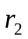.
a) 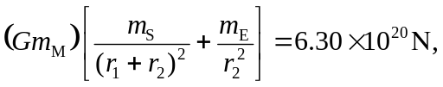
toward the sun. b)The earth-moon distance is sufficiently small compared to the earth-sun distance (r₂ << r₂) that the vector from the earth to the moon can be taken to be perpendicular to the vector from the sun to the moon. The components of the gravitational force are then

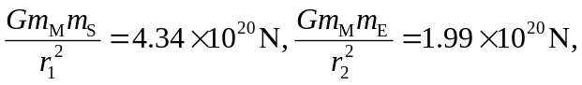
and so the force has magnitude 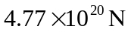 and is directed 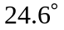 from the direction toward the sun.

c) 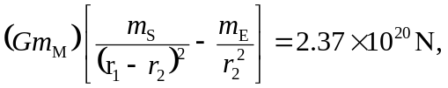
toward the sun.

